Question 1: Truncated Y-Axis in Sales Growth
1. Why is the chart misleading?
The Y-axis starts at 90 instead of 0. Therefore, the difference between ₹95 lakhs and ₹105 lakhs looks much larger than it actually is.
Actual increase:
₹105 − ₹95 = ₹10 lakhs
The chart may make June appear almost twice as high as January, even though June sales are only about 10.5% higher.
2. Violated visualization principle
The chart violates the principle of using an appropriate and honest baseline, especially for bar charts. Bar charts should normally start from zero because bar length represents quantity.
3. Improved visualization
Use a bar chart with the Y-axis starting at 0.
Alternatively, a line chart can be used to clearly show the gradual monthly growth.
4. Effect on business decisions
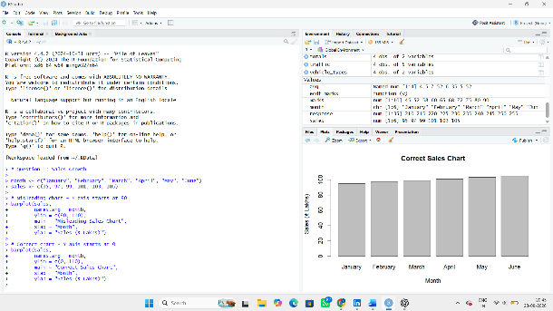
The misleading chart could make management believe that sales have increased dramatically. This could result in:
- Overestimating business growth
- Increasing production unnecessarily
- Spending more on marketing
- Setting unrealistic sales targets
- Making incorrect investment decisions
Question 2: Pie Chart with Incorrect Proportions
Total students:
420 + 280 + 200 + 100 = 1,000 students
1. Correct percentages
Department | Students | Correct Percentage
Computer Science | 420 | 42%
Electronics | 280 | 28%
Mechanical | 200 | 20%
Civil | 100 | 10%
Total | 1000 | 100%
2. Why is the displayed chart misleading?
The chart uses approximately 50%, 30%, 15%, and 15%, instead of the correct 42%, 28%, 20%, and 10%.
In particular, Civil is shown as 15% instead of 10%, while Computer Science is shown as 50% instead of 42%.
Therefore, the visual size of the slices does not represent the actual enrollment.
3. Alternative visualization
A bar chart would be better because it makes it easier to compare the number of students in each department accurately.
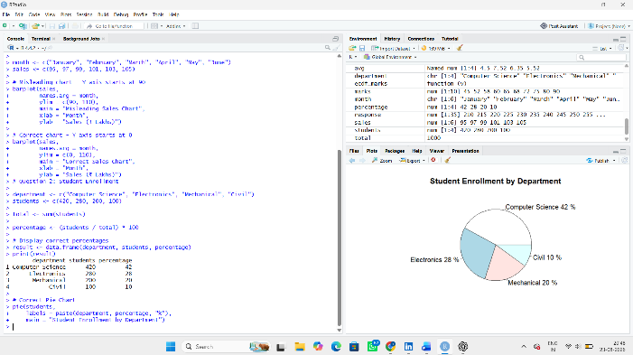
4. Effect on institutional planning
Incorrect enrollment information could lead to:
- Wrong allocation of classrooms
- Incorrect faculty requirements
- Improper laboratory planning
- Incorrect budget allocation
- Insufficient infrastructure for larger departments
Question 3: Unequal Bar Widths in Revenue Comparison
Given:
Product | Revenue (₹ Crores)
A | 60
B | 75
C | 90
D | 105
1. Graphical error
The error is the use of unequal bar widths in a standard bar chart.
2. How do unequal widths distort perception?
In a bar chart, viewers compare the height/length of bars.
When both height and width increase, the visual area of the bar also increases. Therefore, Product D can look much larger than Product A even though:
105 / 60 = 1.75
So D's revenue is only 1.75 times A's revenue, not nearly three times.
3. Correct visualization principles
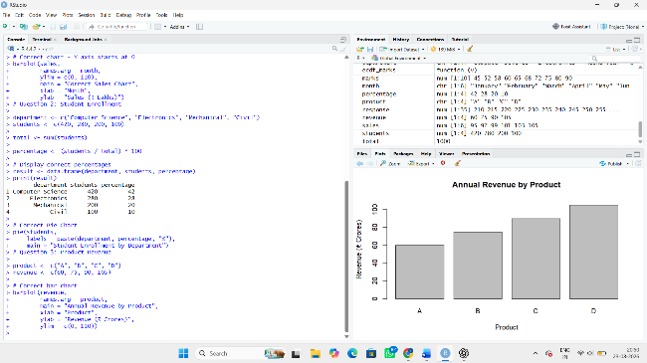
The redesigned chart should:
- Use equal-width bars
- Use a consistent scale
- Start the Y-axis at 0
- Label the revenue values clearly
- Avoid unnecessary 3D effects
- Use the same baseline for all products
A simple 2D bar chart is appropriate.
4. Consequences for investors
Investors may incorrectly believe that Product D is far more profitable or successful than Product A. This could influence:
- Investment decisions
- Product funding
- Company valuation
- Resource allocation
- Business strategy
Question 4: 3D Column Chart Distortion
Given data:
Source | Energy (GWh)
Solar | 450
Wind | 500
Hydro | 550
Biomass | 520
1. Why can 3D charts be misleading?
3D charts use perspective, depth, and viewing angles. Objects closer to the viewer can appear larger than objects farther away.
As a result, the apparent size of a column may not accurately represent its actual value.
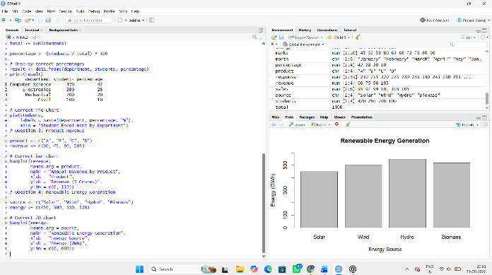
2. Perceived vs actual difference
For Wind:
500 GWh
For Hydro:
550 GWh
Actual difference:
550 − 500 = 50 GWh
Percentage difference relative to Wind:
(50 / 500) × 100 = 10%
So Hydro is actually only 10% higher than Wind, but the 3D perspective makes it appear almost 40% larger.
3. Better visualization
Use a simple 2D bar/column chart with:
- Equal-width bars
- Consistent scale
- Zero baseline
- Clear labels
- No perspective or 3D effects
4. Importance in sustainability reporting
Sustainability reports influence investors, regulators, customers, and the public. Visual distortion can cause people to misunderstand the organization's renewable-energy performance.
Accurate visualization helps ensure:
- Transparent reporting
- Correct investment decisions
- Reliable sustainability comparisons
- Better environmental planning
- Greater stakeholder trust
Question 5: Bubble Chart with Incorrect Scaling
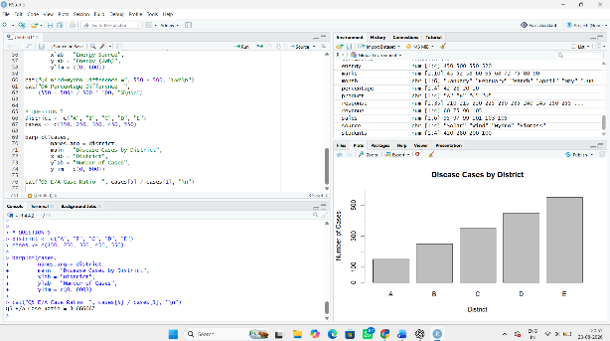
Given data:
District | Cases
A | 150
B | 250
C | 350
D | 450
E | 550
1. Why is radius scaling misleading?
In a bubble chart, people perceive the area of a circle, not just its radius.
Circle area is:
Area = πr²
If the radius is directly proportional to the number of cases, the area increases with the square of the cases.
For example:
- District A = 150 cases
- District E = 550 cases
Actual case ratio:
550 / 150 ≈ 3.67
So E has about 3.67 times as many cases as A.
But if radius is scaled directly to cases, the visual area becomes approximately:
(550 / 150)² ≈ 13.44
Therefore, E can appear more than 13 times larger in area, which is highly misleading.
2. Correct bubble-sizing method
The bubble area, not the radius, should be proportional to the number of cases.
Since:
Area = πr²
the radius should be proportional to:
√(number of cases)
This ensures that the visual area correctly represents the data.
3. Alternative visualization
A bar chart would be more suitable because there are only five districts and the cases can be compared easily.
A horizontal bar chart would provide a particularly clear comparison.
4. Impact on public health resource allocation
A misleading chart could make authorities think that one district has a much more severe disease problem than it actually does.
This could result in:
- Excessive resources being sent to one district
- Insufficient resources for other districts
- Incorrect allocation of medical staff
- Improper medicine distribution
- Poor disease-control planning

